# Part 1: Create the Pig Dice game

Part 1 of this case study has you create the Pig Dice game.

Prerequisites: Chapters 1 to 6.

## User interface

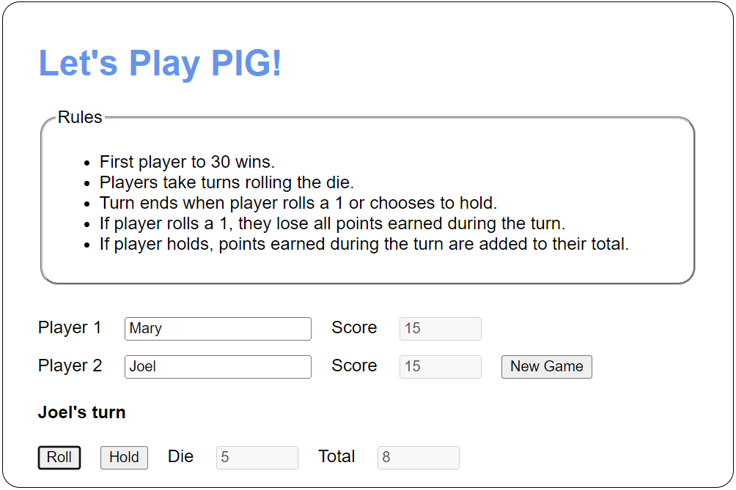

## Specifications

* The rules are displayed in the screen capture above.
* The turn message, Roll/Hold buttons, and Die/Total text boxes should not be visible until the New Game button is clicked.
* When the New Game Button is clicked, it should verify that both of the player text boxes contain a valid user name. If not, the app should notify the user. If so, the app should display the turn message, the Roll/Hold buttons, and Die/Total text boxes.
* Clicking the Roll button should roll the die and display its value in the Die text box. If the value is 1, the app should set the current turn total to 0 and switch the turn to the other player. Otherwise, the app should add the value of the roll to the current turn total, display the current turn total in the Total text box, and allow the current player to roll again or hold.
* Clicking the Hold button should add the total for the current turn to the Score text box and check to see if the current player won. If they did, the app should notify the user. Otherwise, the app should set the current turn total to 0 and switch the turn to the other player.